**DEVELOPMENT PART 2**

**PROJECT TITLE: SMART WATER MANAGEMENT SYSTEM**

**INTRODUCTION:**

1. Smart water management systems represent a crucial step forward in optimizing the way we handle and utilize water resources. These systems leverage advanced technologies to monitor, control, and enhance the efficiency of water usage across various sectors. By integrating sensors, data analytics, and communication technologies, smart water management systems provide real-time insights and enable intelligent decision-making to ensure sustainable water practices. From residential to industrial settings, these systems play a pivotal role in addressing water scarcity challenges and promoting conservation. Overall, the introduction of smart water management is a watershed moment (pun intended!) in our quest for a more responsible and sustainable approach to water resources.
2. A Smart Water Management System (SWMS) is a sophisticated and integrated solution designed to monitor, control, and optimize water usage in various environments. As water scarcity becomes a global concern, the need for efficient water management systems has grown significantly. SWMS leverages advanced technologies, data analytics, and automation to enhance the overall management of water resources.

**ALGORITHM:**

Step1: Start

Step2: Find a user-friendly platform for user convenient.

Step3: Collect the Data from Variety of Sources such as Sensors, Smart meters , and Weather forecasts,etc.

Step4: Analyze the Data.

Step5: Connect the sources (sensors,weather forecast,etc) to the given Board like Arduino UNO, Raspberry pi ,etc.

Step6: Make a decision like allocate the water supply.

Step7: Check the Board Connection and Run the code.

**IDEA FOR THE SOLUTION:**

Smart water management systems (SWMS) offer a comprehensive approach to optimizing water usage and conservation efforts. These solutions encompass a range of innovative technologies and strategies that can be tailored to specific needs and environments. Here are some key ideas for implementing effective SWMS solutions:

1. **Real-time monitoring and data analytics:** Deploy a network of sensors throughout the water infrastructure to collect real-time data on water flow, pressure, quality, and consumption patterns. Utilize data analytics tools to process and interpret this information, providing insights into potential leaks, inefficiencies, and areas for improvement.
2. **Leak detection and prevention:** Employ advanced leak detection technologies, such as acoustic sensors and pressure monitoring systems, to identify leaks promptly and accurately. Implement proactive leak prevention measures, including infrastructure maintenance programs and pressure management strategies.
3. **Demand-based water management:** Implement smart metering systems that provide detailed water usage data for individual consumers or specific areas. Utilize this data to implement demand-based pricing structures and encourage water conservation practices.
4. **Smart irrigation systems:** Implement intelligent irrigation systems that adjust watering schedules based on real-time weather data, soil moisture sensors, and plant water requirements. This approach optimizes water usage for landscaping and agriculture, reducing waste and conserving resources.
5. **Water quality monitoring and treatment:** Utilize real-time water quality monitoring systems to detect potential contaminants and ensure adherence to safety standards. Implement smart control systems for water treatment processes, optimizing chemical dosing and ensuring effective purification.
6. **Predictive maintenance and risk mitigation:** Leverage machine learning algorithms to analyze historical data and predict potential equipment failures or system disruptions. Implement preventive maintenance schedules and risk mitigation strategies to enhance system resilience and minimize downtime.
7. **Cybersecurity and data protection:** Employ robust cybersecurity measures to protect SWMS data and infrastructure from cyberattacks. Implement secure data transmission protocols, access controls, and intrusion detection systems to safeguard sensitive information.
8. **Community engagement and education:** Raise awareness about water conservation and the benefits of smart water management practices. Engage with communities and stakeholders to promote behavioral changes and encourage responsible water usage habits.
9. **Collaborative partnerships and data sharing:** Foster partnerships among water utilities, municipalities, and technology providers to share data, expertise, and best practices. Collaborative efforts can accelerate innovation and enhance the effectiveness of SWMS implementations.
10. **Continuous improvement and adaptability:** Implement a continuous improvement cycle for SWMS, incorporating feedback from users, analyzing performance data, and adapting to changing conditions. This approach ensures that the system remains effective and responsive to evolving needs.

**TOOLS AND TECHNOLOGIES:**

Smart water management systems (SWMS) utilize a variety of tools and technologies to monitor, analyze, and control water resources. Some of the most common tools and technologies used in SWMS include:

* **Sensors:** Sensors collect real-time data on water flow, pressure, quality, and other parameters. This data is essential for monitoring water systems, identifying leaks and other problems, and optimizing water usage.
* **Data analytics software:** Data analytics software is used to process and analyze sensor data. This software can identify patterns and trends in the data, which can be used to improve water system performance and efficiency.
* **Machine learning algorithms:** Machine learning algorithms are used to predict water demand, identify potential leaks, and optimize water treatment processes. Machine learning can also be used to develop personalized water conservation recommendations for consumers.
* **Control systems:** Control systems are used to automate actions based on the insights gained from data analytics and machine learning. For example, control systems can be used to adjust water pressure, open and close valves, and turn on and off pumps.

In addition to these core tools and technologies, SWMS may also incorporate other technologies such as:

* **Internet of Things (IoT) platforms:** IoT platforms provide a way to connect sensors, devices, and software applications to the cloud. This enables real-time data sharing and collaboration among different stakeholders in the water management process.
* **Geographic information systems (GIS):** GIS can be used to visualize and analyze water system data on a map. This can help to identify potential problems, such as leaks near critical infrastructure or areas with high water demand.
* **Decision support systems (DSS):** DSS provide water managers with tools to support decision-making. These systems can incorporate data analytics, machine learning, and GIS to help managers to evaluate different options and make informed decisions about water resource management.

The specific tools and technologies used in a SWMS will vary depending on the specific needs and resources of the organization. However, the core technologies listed above are essential for developing and implementing effective SWMS solutions.

Here are some examples of how specific tools and technologies are being used in SWMS today:

* **Smart water meters:** Smart water meters provide real-time data on water usage, which can be used to identify leaks and reduce water waste.
* **Acoustic leak detection systems:** Acoustic leak detection systems use microphones to detect the sound of water leaks. These systems can be used to identify leaks that are difficult to find with traditional methods.
* **Pressure monitoring systems:** Pressure monitoring systems can be used to detect changes in water pressure, which can be an indication of a leak or other problem.
* **Water quality monitoring systems:** Water quality monitoring systems can be used to monitor water quality for a variety of parameters, including pH, turbidity, and bacterial contamination.
* **Machine learning algorithms:** Machine learning algorithms are being used to predict water demand, identify potential leaks, and optimize water treatment processes. For example, machine learning algorithms can be used to predict water demand based on weather data and historical usage patterns.
* **Control systems:** Control systems are being used to automate water system operations, such as adjusting water pressure, opening and closing valves, and turning on and off pumps.

SWMS are rapidly evolving as new technologies and tools emerge. By leveraging these innovative solutions, water utilities and organizations can improve water efficiency, conservation, and resilience.

**BOARDS AND LANGUAGES:**

The boards and programming languages used in smart water management systems (SWMS) vary depending on the specific needs and requirements of the system. However, some of the most common boards and programming languages used in SWMS include:

**i) Boards:**

* Arduino: Arduino is a popular open-source electronics platform that is used for a wide variety of applications, including SWMS. Arduino boards are relatively inexpensive and easy to use, making them a good choice for developing and implementing SWMS prototypes.
* Raspberry Pi: Raspberry Pi is a low-cost, single-board computer that is also commonly used in SWMS. Raspberry Pi boards are more powerful than Arduino boards, making them a good choice for developing more complex SWMS solutions.
* BeagleBone: BeagleBone is another popular single-board computer that is used in SWMS. BeagleBone boards are similar to Raspberry Pi boards in terms of performance, but they offer some additional features, such as more GPIO pins and a faster processor.

**ii) Programming languages:**

* Python: Python is a general-purpose programming language that is popular for SWMS development. Python is easy to learn and use, and it offers a wide range of libraries and tools for developing SWMS applications.
* C/C++: C and C++ are low-level programming languages that are often used for developing performance-critical SWMS applications. C and C++ offer more control over hardware resources than Python, but they are also more difficult to learn and use.
* Java: Java is a general-purpose programming language that is sometimes used for SWMS development. Java is a good choice for developing cross-platform SWMS applications, but it can be slower than Python or C/C++.

The specific board and programming language used in a SWMS will vary depending on the specific needs and requirements of the system. However, the boards and programming languages listed above are a good starting point for developing and implementing SWMS solutions.

Here are some examples of how specific boards and programming languages are being used in SWMS today:

* Arduino: Arduino boards are often used to develop prototypes of SWMS solutions. For example, Arduino boards can be used to develop simple irrigation systems or water monitoring systems.
* Raspberry Pi: Raspberry Pi boards are often used to develop more complex SWMS solutions. For example, Raspberry Pi boards can be used to develop water distribution control systems or water quality monitoring systems.
* Python: Python is a popular programming language for developing SWMS applications. For example, Python can be used to develop applications for monitoring and controlling water distribution systems, irrigation systems, and water treatment systems.
* C/C++: C and C++ are often used for developing performance-critical SWMS applications. For example, C and C++ can be used to develop real-time control systems for water distribution systems or wastewater treatment plants.
* Java: Java is sometimes used for developing cross-platform SWMS applications. For example, Java can be used to develop applications for monitoring and controlling water systems from a variety of devices, such as smartphones, tablets, and laptops.

SWMS are rapidly evolving as new technologies and tools emerge. By leveraging these innovative solutions, water utilities and organizations can improve water efficiency, conservation, and resilience.

**PROCEDURE:**

**ADVANCE TECHNIQUES IN SMART WATER MANAGEMENT:**

Advanced smart water management systems use artificial intelligence (AI), machine learning (ML), and the Internet of Things (IoT) to collect and analyze data from a variety of sources, including weather forecasts, water meters, and sensors. This data is then used to make informed decisions about how to manage water resources more efficiently and sustainably.

Here are some specific examples of advanced smart water management procedures:

* **Predictive maintenance**: AI and ML can be used to analyze data from water sensors to predict when pumps, pipes, and other infrastructure are likely to fail. This information can be used to schedule preventive maintenance, which can help to avoid costly and disruptive unplanned outages.
* **Real-time leak detection**: AI and ML can also be used to detect leaks in water pipes in real time. This information can be used to quickly identify and repair leaks, which can save water and money.
* **Demand management**: AI and ML can be used to forecast water demand based on historical data and weather forecasts. This information can be used to adjust water pressure and flow to meet demand, which can help to reduce waste.
* **Water quality monitoring**: AI and ML can be used to analyze data from water quality sensors to monitor for contaminants and other problems. This information can be used to ensure that drinking water is safe and to identify and address water quality issues early on.
* In addition to these specific procedures, advanced smart water management systems can also be used to develop and implement more comprehensive water management strategies. For example, a smart water management system could be used to create a digital twin of a water distribution system. This digital twin could be used to simulate different scenarios and identify the best way to manage the system under different conditions.

Advanced smart water management systems are still under development, but they have the potential to revolutionize the way we manage water resources. By using AI, ML, and IoT to collect and analyze data, we can develop more efficient and sustainable ways to use water.

Here are some specific examples of how advanced smart water management systems are being used today:

* The city of Barcelona, Spain is using a smart water management system to reduce water consumption. The system uses AI to analyze data from water meters and sensors to identify areas where water is being wasted. The city has been able to reduce water consumption by 25% since implementing the system.
* The city of Singapore is using a smart water management system to prevent flooding. The system uses AI to analyze data from weather forecasts and water sensors to predict where flooding is likely to occur. The city can then take steps to mitigate the risk of flooding, such as closing roads and deploying sandbags.
* The state of California is using a smart water management system to improve water quality. The system uses AI to analyze data from water quality sensors to identify and address water quality issues early on. The state has been able to reduce the number of water quality violations by 50% since implementing the system.

These are just a few examples of how advanced smart water management systems are being used today to improve water management efficiency, sustainability, and resilience. As the technology continues to develop, we can expect to see even more innovative and effective ways to use smart water management to protect this precious resource.

Advanced procedures for smart water management systems include:

* Using artificial intelligence (AI) to improve decision-making: AI can be used to analyze large amounts of data from sensors and other sources to identify patterns and trends. This information can be used to make more informed decisions about water management, such as when to water crops, how to allocate water resources, and how to predict and respond to extreme weather events.
* Developing and deploying digital twins: A digital twin is a virtual representation of a physical system, such as a water distribution network. Digital twins can be used to simulate the behavior of the system under different conditions and to identify potential problems. This information can be used to improve the design and operation of the system.
* Integrating with other smart city systems: Smart water management systems can be integrated with other smart city systems, such as smart transportation and smart energy systems. This integration can lead to more efficient and sustainable water management.

Here are some specific examples of advanced procedures that can be used in smart water management systems:

* Using AI to predict water demand: AI can be used to predict water demand based on a variety of factors, such as historical data, weather conditions, and social media data. This information can be used to optimize water distribution and reduce waste.
* Developing digital twins of water distribution networks: Digital twins of water distribution networks can be used to simulate the behavior of the network under different conditions, such as pipe breaks or changes in demand. This information can be used to identify potential problems and to develop strategies for mitigating their impact.
* Integrating smart water management systems with smart transportation systems: Smart water management systems can be integrated with smart transportation systems to optimize traffic flow and reduce water consumption. For example, smart water meters can be used to detect leaks in water pipes, and this information can be transmitted to smart traffic lights to adjust the timing of the lights and reduce congestion.

Advanced procedures for smart water management systems are still under development, but they have the potential to revolutionize the way that water is managed. By using AI, digital twins, and integration with other smart city systems, smart water management systems can help to ensure that water is used efficiently and sustainably.

In addition to the above, here are some other areas where advanced procedures for smart water management systems are being developed:

* Using blockchain technology to improve transparency and security: Blockchain technology can be used to create a tamper-proof record of water transactions. This can help to improve transparency and security in the water sector.
* Using machine learning to detect and predict waterborne diseases: Machine learning can be used to analyze data from water quality sensors to detect and predict waterborne diseases. This information can be used to prevent outbreaks and to protect public health.
* Using drones and other robotics to inspect and repair water infrastructure: Drones and other robots can be used to inspect and repair water infrastructure, such as pipes and dams. This can help to improve the efficiency and safety of water management operations.

Advanced procedures for smart water management systems have the potential to make a significant contribution to addressing the global water crisis. By using innovative technologies to improve the efficiency and sustainability of water management, we can help to ensure that everyone has access to clean and safe water.

**BLOCK DIAGRAM:**

**i)*Existing System:***

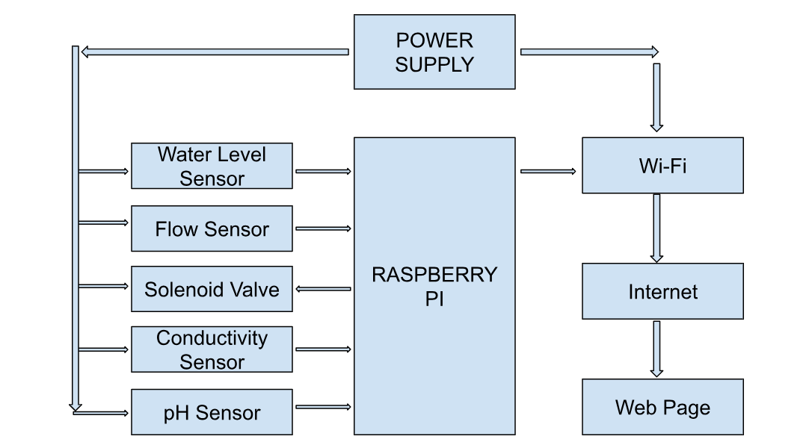

**ii)*Proposed System:***

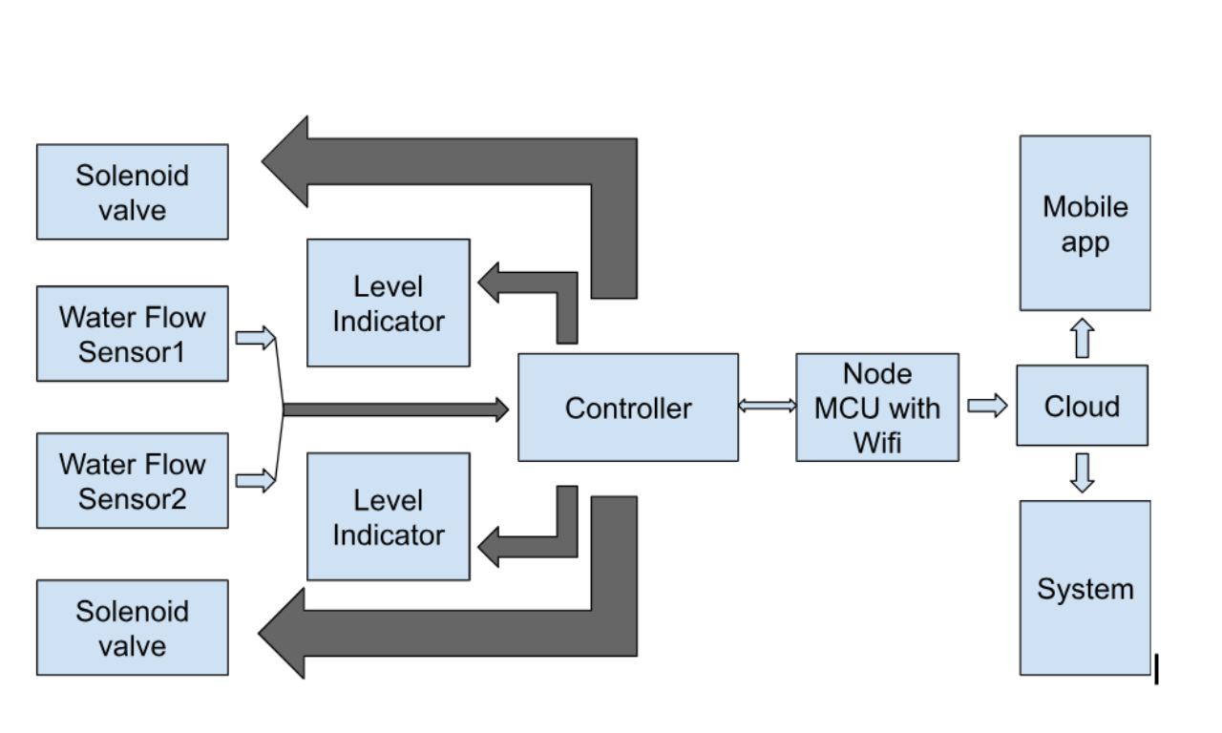

**BLOCK DIAGRAM IN REAL TIME:**



**PROGRAM: (water level)**

import time

import board

import analogio

import paho.mqtt.client as mqtt

# Define the pin for the water level sensor

water_level_sensor_pin = analogio.AnalogIn(board.A0)

# Define the MQTT broker address

mqtt_broker_address = "localhost"

# Define the MQTT topic

mqtt_topic = "water_level"

# Connect to the MQTT broker

client = mqtt.Client()

client.connect(mqtt_broker_address)

# Define a function to read the water level sensor value

def read_water_level():

# Read the water level sensor value

water_level_sensor_value = water_level_sensor_pin.value

# Convert the water level sensor value to a voltage

water_level_sensor_voltage = water_level_sensor_value * 5

# Convert the voltage to a water level

water_level = water_level_sensor_voltage / 10

# Return the water level

return water_level

# Start a loop to monitor the water level

while True:

# Read the water level

water_level = read_water_level()

# Publish the water level to the MQTT topic

client.publish(mqtt_topic, str(water_level))

# Wait for 1 second

time.sleep(1)

**SIMULATION DIAGRAM:**

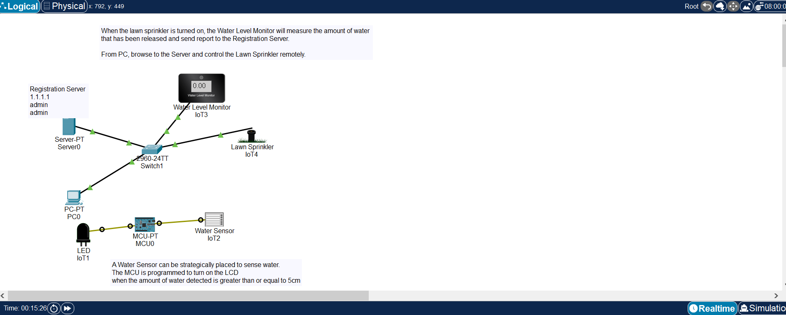

**PROGRAM:(Measure the pH level of Water)**

import pandas as pd

import matplotlib.pyplot as plt

import numpy as np

fil = pd.read_csv('https://raw.githubusercontent.com/andreasdh/programmering-i-kjemi/master/docs/datafiler/titreringsdata.txt', delimiter = ",")

volum = fil['volum']

pH = fil['pH']

print(pH, volum)

plt.plot(volum, pH, color = "#B00B69", label = "Tilpasset modell")

plt.scatter(volum, pH, color = "hotpink", label = "Datapunkter")

plt.xlabel("volum")

plt.ylabel("pH")

plt.grid()

plt.show()

d = []

for i in range(len(volum)-1):

dery = pH[i+1] - pH[i]

dert = volum[i+1] - volum[i]

dydt = dery/dert

d.append(dydt)

print(d)

def fmax(list):

max = list[0]

for x in list:

if x > max:

max = x

return max

print('the biggest element in the derivative is', fmax(d))

**OUTPUT:(Data Analytics of pH level)**

0 2.51

1 2.76

2 3.03

3 3.11

4 3.31

5 3.42

6 3.54

7 3.66

8 3.79

9 3.83

10 3.98

11 4.10

12 4.21

13 4.27

14 4.35

15 4.41

16 4.50

17 4.61

18 4.78

19 4.86

20 5.12

21 5.28

22 5.54

23 5.98

24 6.31

25 8.70

26 9.49

27 9.97

28 10.23

29 10.42

30 10.81

31 11.09

32 11.19

33 11.39

34 11.53

35 11.71

36 11.82

37 11.92

38 11.95

39 11.99

40 12.05

41 12.12

Name: pH, dtype: float64 0 0.00

1 2.05

2 4.00

3 6.01

4 8.22

5 10.04

6 12.35

7 14.25

8 16.06

9 18.15

10 20.21

11 22.01

12 24.13

13 25.04

14 26.10

15 27.06

16 28.01

17 29.20

18 30.22

19 30.97

20 31.96

21 32.38

22 32.86

23 33.20

24 33.36

25 33.52

26 33.56

27 33.67

28 33.82

29 33.87

30 34.13

31 34.64

32 34.94

33 35.86

34 37.12

35 39.00

36 41.01

37 43.08

38 44.22

39 45.62

40 47.73

41 50.00

Name: volum, dtype: float64

**VISUAL REPRESENTATION OF DATA:**

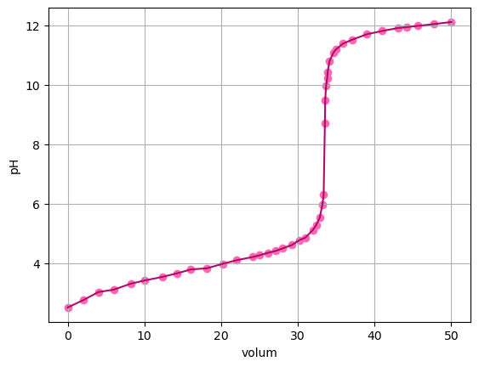

**[0.12195121951219513, 0.13846153846153847, 0.03980099502487566, 0.09049773755656113, 0.06043956043956042, 0.051948051948051986, 0.06315789473684215, 0.0718232044198895, 0.01913875598086126, 0.0728155339805824, 0.06666666666666646, 0.0518867924528304, 0.06593406593406549, 0.07547169811320745, 0.0625000000000007, 0.09473684210526273, 0.09243697478991642, 0.16666666666666666, 0.10666666666666676, 0.2626262626262619, 0.38095238095237977, 0.5416666666666697, 1.2941176470588116, 2.062500000000039, 14.937499999999654, 19.750000000000444, 4.36363636363639, 1.7333333333333483, 3.800000000000206, 1.4999999999999727, 0.5490196078431382, 0.3333333333333353, 0.21739130434782683, 0.11111111111111033, 0.0957446808510645, 0.05472636815920375, 0.04830917874396117, 0.026315789473683637, 0.02857142857142926, 0.028436018957346217, 0.030837004405285643]**

**the biggest element in the derivative is 19.750000000000444**

**PROGRAM: (leakage detection)**

import RPi.GPIO as GPIO

import smtplib

# Set the GPIO pin to be an input

GPIO.setmode(GPIO.BCM)

GPIO.setup(18, GPIO.IN)

# Create an SMTP object

smtpObj = smtplib.SMTP('smtp.gmail.com', 587)

smtpObj.starttls()

smtpObj.login('your_email_address@gmail.com', 'your_password')

def send_email_alert():

smtpObj.sendmail('your_email_address@gmail.com', 'your_email_address@gmail.com', 'Leak detected!')

# Read the leak sensor

leak_sensor_value = GPIO.input(18)

# Check if a leak is detected

if leak_sensor_value == GPIO.HIGH:

send_email_alert()

smtpObj.quit()

**CONCLUSION:**

Smart water management (SWM) is the use of technology to improve the efficiency, sustainability, and resilience of water resources. SWM systems can be used to monitor and manage water distribution networks, wastewater treatment plants, irrigation systems, and other water-related infrastructure.

SWM systems use a variety of sensors, data analytics tools, and machine learning algorithms to collect, analyze, and interpret data about water usage, quality, and flow. This information is then used to make informed decisions about how to manage water resources more effectively.